GLOSSARY

ASL: American Sign Language; Naturally evolved signed language of deaf Americans.

MCE: Manually Coded English; Umbrella term for invented manual codes that attempt to represent the morphemes of English on the hands.

Consistent Input: Forms and meanings are matched in a regular pattern.

Inconsistent input: Forms and meanings are not matched in a regular pattern (as they generally are in normal language input).

Overregularization: Error children make in normal language acquisition; they over-apply the regular past tense morpheme “ed” and they say things like “I eated the apple” or “I catched the ball.”

Pidgins: Develop when adult speakers who have no common language come in contact (e.g. slave populations, trade); limited vocabulary, no complex sentence structure, inconsistent grammars. No native speakers.

Creoles: Develop from the children of pidgin speakers who learn the pidgin as their native language; more structural regularity than pidgins.

Native Speaker/Signer: Learned primary language from birth.

Non-native Speaker/Signer: Learned a language after childhood.

Morpheme: Smallest part of a word that has meaning (English past-tense "ed").

Learning Biases: General principles the child brings to the language acquisition process. They help the learning process by constraining the kinds of possible generalizations and errors the child can make, given the input.

Verbs of Motion: describe how objects move in space.

ASL verb of motion: Formed by combining several morphemes: There are several kinds of movement morphemes and 2 kinds of classifier morphemes.

Movement Morphemes: part of the verb that expresses how the object moves in space: straight line, around the corner, bouncing, rolling…

Path: Shape of path from point A to point B (linear, turn, etc.).

Manner: How object moves along path (rolling, bouncing, etc.).

Direction: Orientation of path (uphill, downhill, up, down, etc.).

Location: Relative position of central and secondary objects (1) to, from, etc. (2) beside, on, etc.

Classifier Morphemes: Handshapes that represent the kind of object that is moving, e.g. person, vehicle, tall thin object.

Central Object: Moving object.

Secondary Object: Stationary object.

ASL SASSes
 | Wide | Medium-Width | Narrow
Straight | 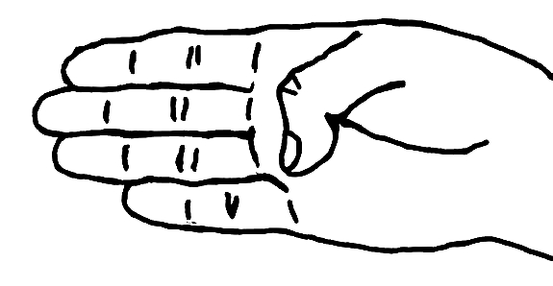 | 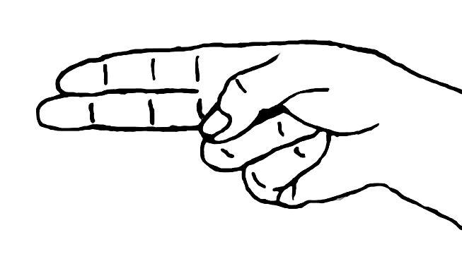 | 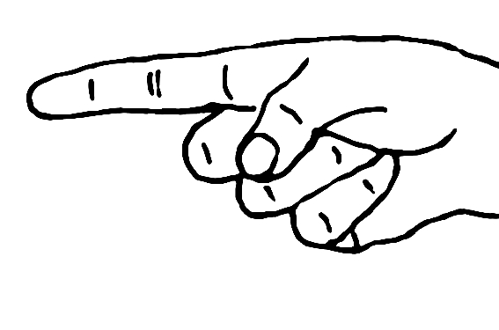
 | B-Straight | H-Straight | Z-Straight
Round | 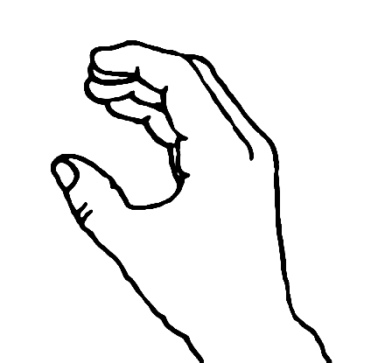 | 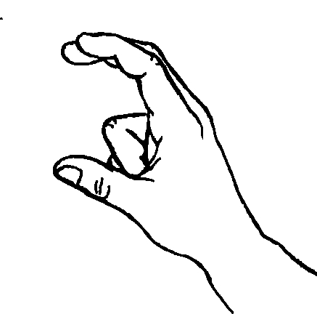 | 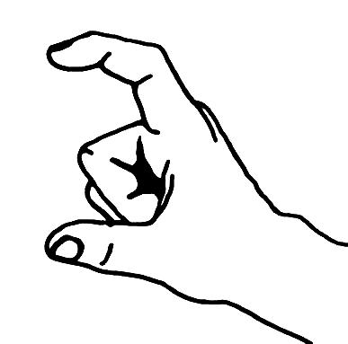
 | BC | HC | ZC

ASL Semantic Classifiers
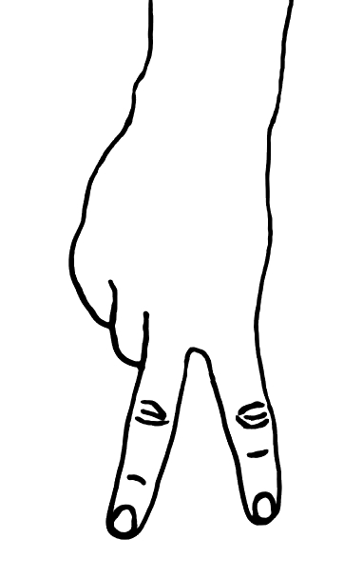 | 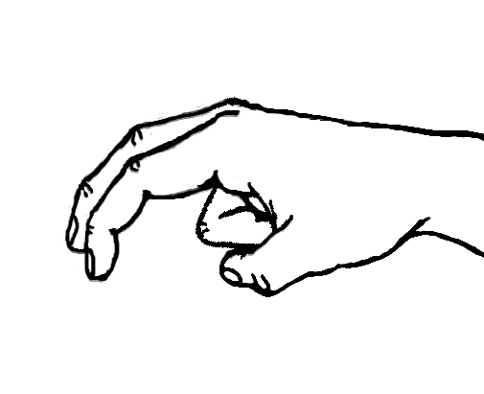 | 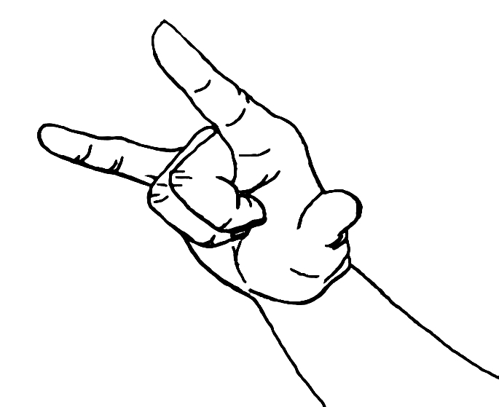
LEGS | LEGS-Bent | PLANE
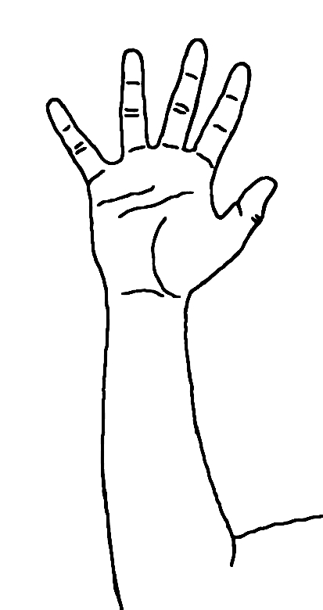 | 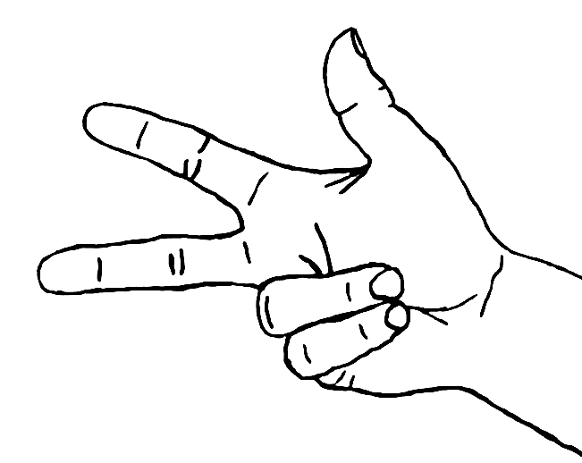
TREE | VEH

Examples of Frozen Verb Signs
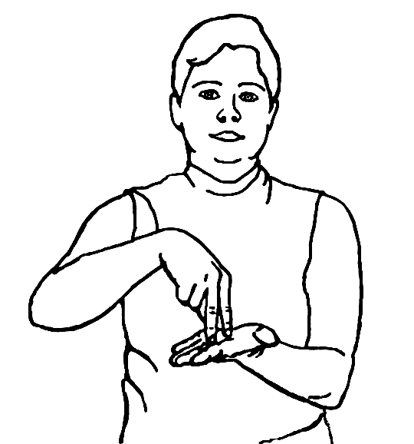 | 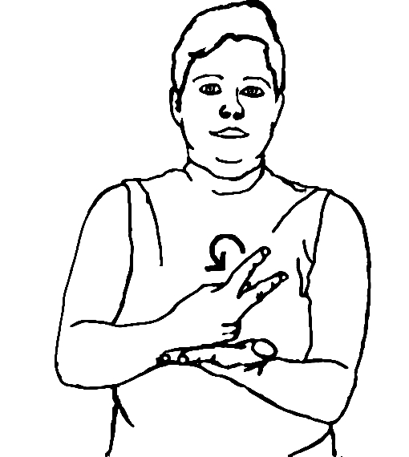
FALL (1) | FALL (2)
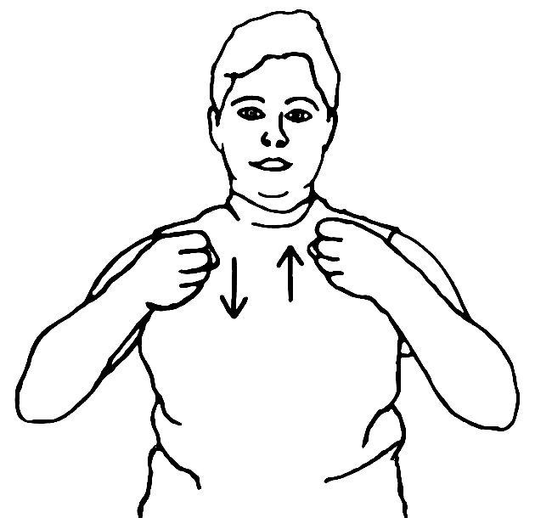
DRIVE

